Clothes and colors
Entoure ( ou mets en gras )les vêtements qui apparaissent en image ci dessous
A brown Hat
Sunglasses
Pullover
White shoes
A green dress
Jeans
Yellow socks
A black tee-shirt
Brown shoes

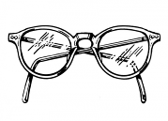 |  | 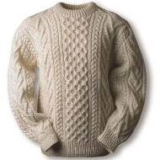
 |  | 