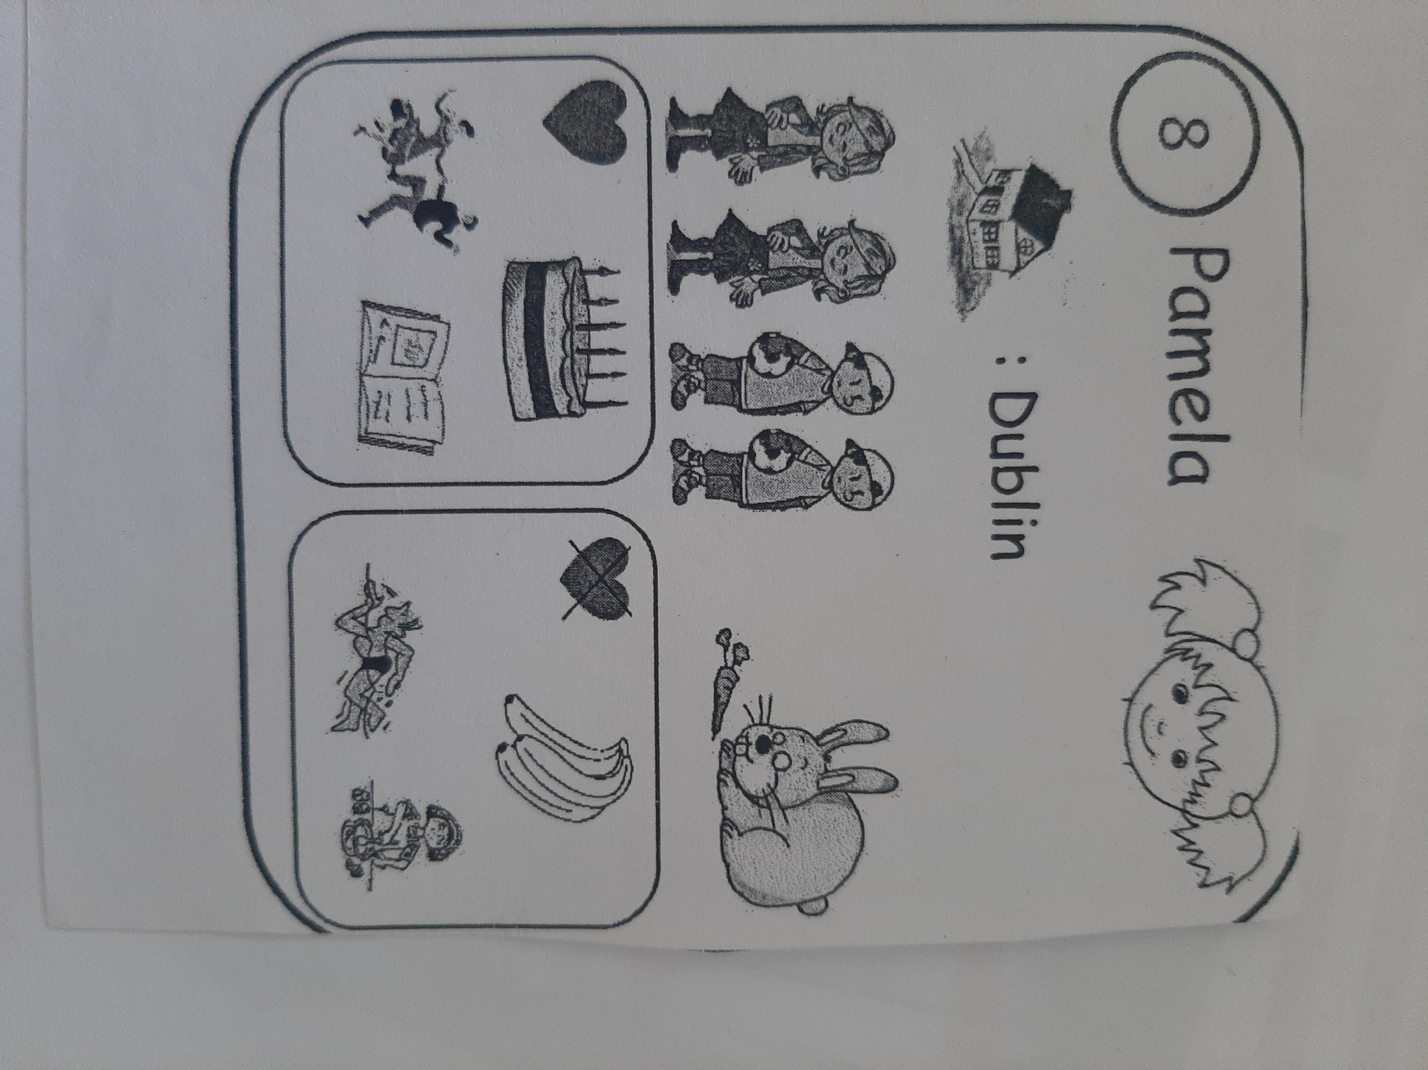
What's her name ?...
Where does she live ?...
How old is she ?.....
Has she got sisters ?.....
Has she got pets ?......
What does she like ?.....

