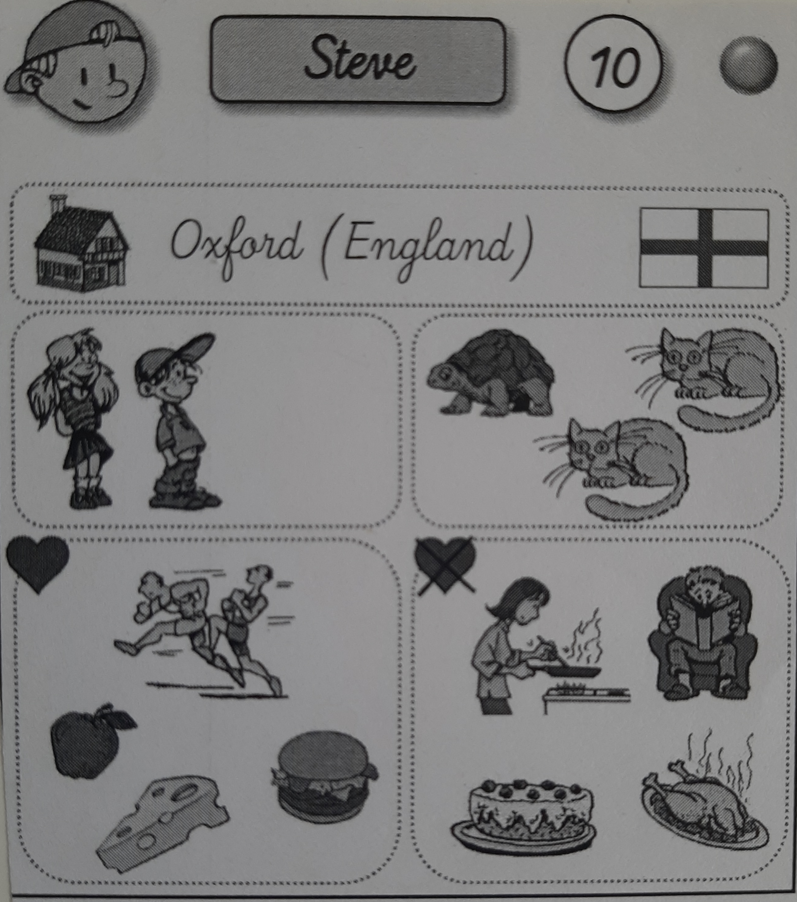
What's his name ?...
Where does he live ?...
How old is he ?.....
Has he got brothers ?.....
Has he got pets ?......
What does he like ?.....

